Mr. John P. Mahoney, Esq.
The Law Firm of John P. Mahoney, Esq., Attorneys at Law, PLLC.

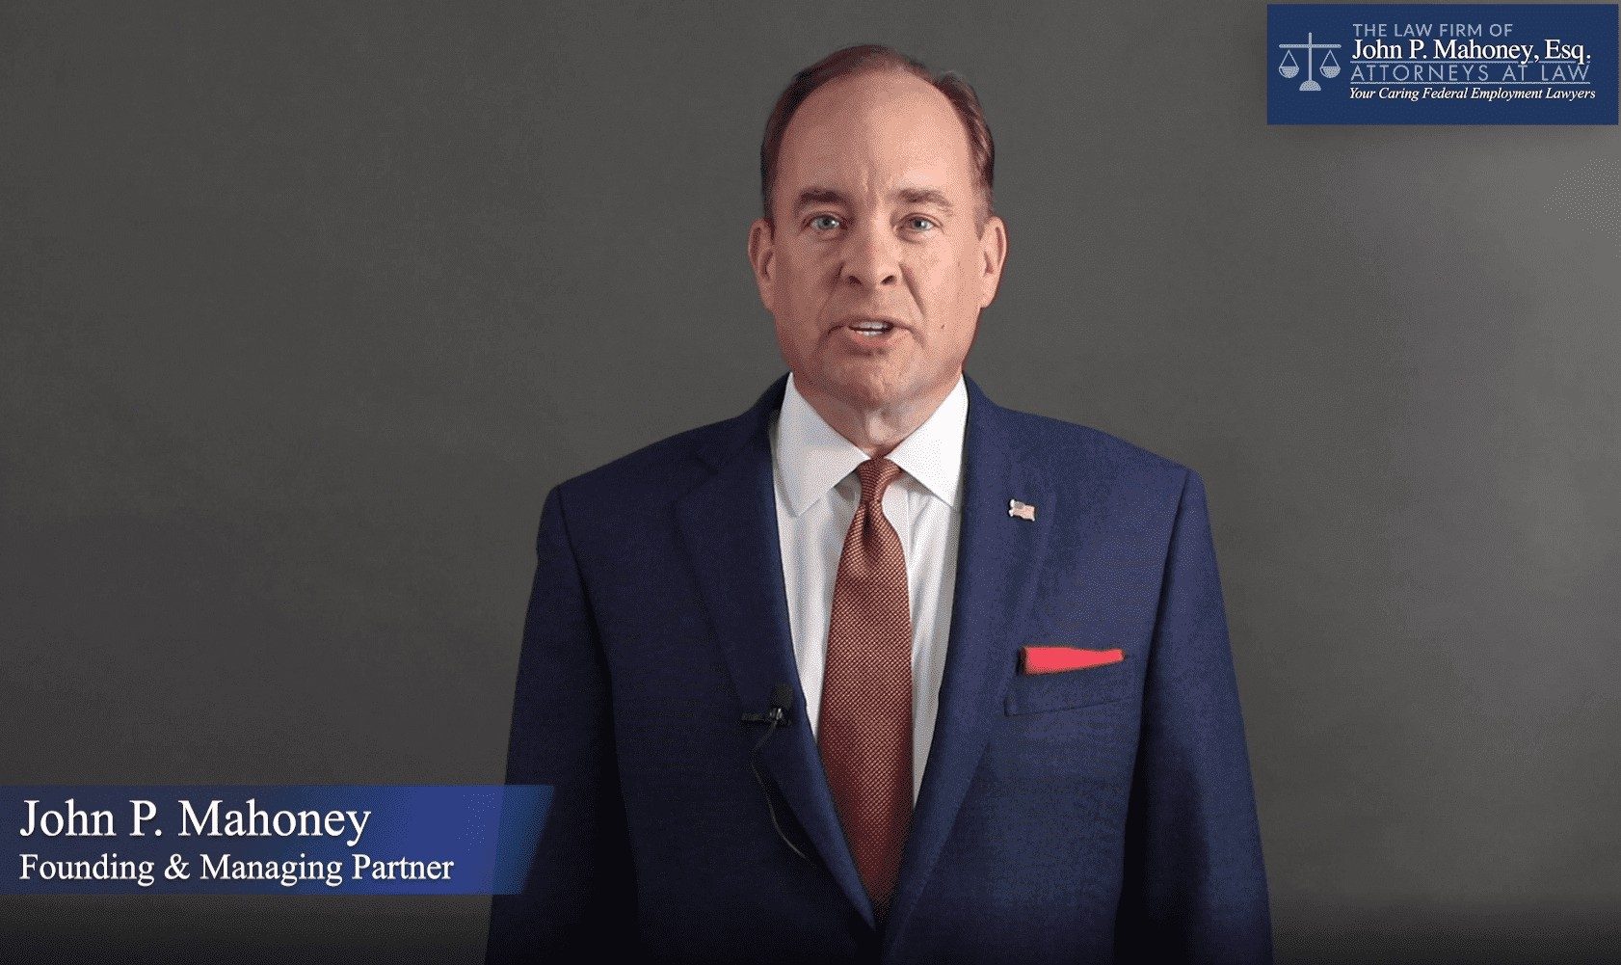

Overview

Attorney John Mahoney is an accomplished legal expert with a focus on federal employment and labor law. As a dedicated Democratic National Committee (DNC) Lawyers Council attorney, John has 30 years of experience in the field. His commitment to public servant clients and passion for justice have earned him recognition as a top attorney in his practice area. John's depth of knowledge and engaging presence make him an ideal guest for top television networks such as MSNBC, CNN, OANN, Fox News, and more.

Bio

John Mahoney earned his Juris Doctor from The Catholic University of America, Columbus School of Law, and began his legal career as a law clerk at the DC Office of Labor Relations & Collective Bargaining. He later served as Vice Chair, an executive, and an Administrative Judge for the U.S. Government Accountability Office’s (GAO), Personnel Appeals Board, where he adjudicated federal employment cases. In his private practice, he has successfully represented thousands of federal employees in various matters before the MSPB, EEOC, and other federal agencies.

As a DNC Lawyer’s Committee member, John has focused on issues related to federal employment law, labor law, and civil rights. He is a member of the Bars of the Supreme Court of the United States, the District of Columbia Bar, and the American Bar Association, further highlighting his commitment to the legal profession.

Expertise

- Federal employment law
- Labor law
- Civil rights
- Administrative law
- Mediation and alternative dispute resolution
- Federal agency litigation
- Employment discrimination
- Security Clearance Appeals

Media Appearances

John has appeared on various media outlets as a legal and political commentator, providing valuable insights on federal employment law, labor law, EEO civil rights matters, national security litigation, and political issues. His extensive background and ability to break down complex legal topics make him a sought-after expert for television news programs.

Suggested Talking Points

- Challenges faced by federal employees in the current political climate
- The role of the DNC in supporting federal employees and their rights
- Updates on key federal employment law cases and legislation
- Strategies for navigating the federal employment system and resolving disputes
- National security clearance appellate litigation
- The future of labor law and civil rights in the United States

For more information about John Mahoney and his legal expertise, please visit his professional website at www.attorneymahoney.com/attorneys/john-p-mahoney-esq-/ and his DC law firm’s webpage at www.AttorneyMahoney.com.

